Animal Tracking Collar

Validation & Testing

**Prepared by:**

Ben Lawson

Ben Shewan

Collin Halamka

Collin Maker

Garrett Harris

**Submitted to:**

Dr. Paul Keenlance

Dr. Jeffrey Ward

Dr. Bruce Dunne

EGR 485/486 Senior Project

Spring/Summer Term 2019

**June 2019**

**[This page intentionally left blank]**

**Table of Contents**

**1.1 GPS Fix Accuracy** **4**

**1.2 VHF Ping Connectivity** **5**

1.2.1 VHF Range 5

1.2.2 VHF On Signal Time 6

1.2.3 VHF Off Signal Time 7

**1.3 XBee Range** **7**

**1.4 Deployment Test** **8**

**2.1 Default Battery Life Validation** **10**

**2.2 Worst Case/High Performance Activity Battery Life** **11**

**2.3 ‘Off’ Mode Battery Shelf Life** **12**

**3.1 Bite Force Testing** **13**

**3.2 Collar Tensile Testing** **15**

**3.3 Claw Catch Testing** **16**

**3.4 Waterproof Testing** **17**

**3.5 Mass Validation (Medium Collar)** **19**

**3.5.1 Mass Validation (Small Collar)** **19**

**3.6 Volume Validation (Medium Collar)** **20**

3.6.1 Small Collar 20

**3.7 Color Validation** **20**

1. Deployment & Functional Validation

Deployment and functional validation testing was conducted to verify the performance of the wildlife GPS tracking collar features. The testing of the device’s features is crucial to ensure the device operates per its specifications when deployed in the field. Functions tested and detailed in this section include: GPS fix accuracy, VHF ping connectivity, range, and on and off time signals, and finally XBee range. The sections detailing the functional deployment testing are shown below.

## 1.1 GPS Fix Accuracy

GPS fix accuracy was tested by the team to determine the accuracy of the data retrieved by the device. A total number of 30 GPS fixes were collected which included; date and time, as well as the longitude and latitude of the device. The average longitudinal and latitudinal differences from the retrieved data and the actual location of the device were then taken. Averaging these differences then provided the devices accuracy percentage of retrieved GPS fixes to its actual location. Data was obtained to ensure proper operation of the device. The validation test results are shown below.

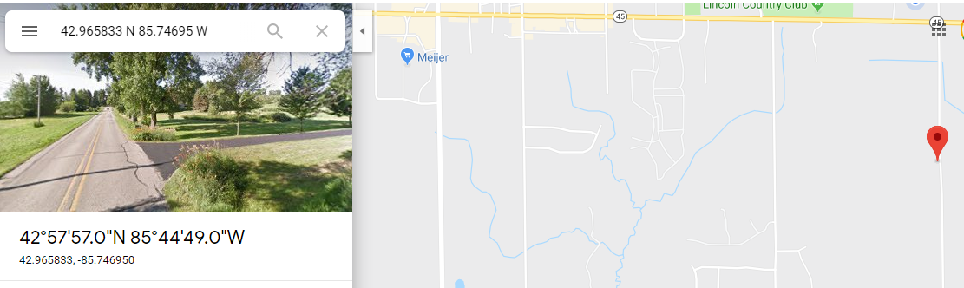

|  |  |  |  |  |  |  |  |  |
| --- | --- | --- | --- | --- | --- | --- | --- | --- |
| Hour | Minute | Day | Month | Year | Northing |  | Easting |  |
| 6 | 10 | 6 | 8 | 19 | 4258.359 | N | 8544.832 | W |
| 6 | 21 | 6 | 8 | 19 | 4258.382 | N | 8544.846 | W |
| 6 | 30 | 6 | 8 | 19 | 4258.385 | N | 8544.84 | W |
| 6 | 40 | 6 | 8 | 19 | 4258.374 | N | 8544.841 | W |
| 6 | 50 | 6 | 8 | 19 | 4258.393 | N | 8544.838 | W |
| 7 | 1 | 6 | 8 | 19 | 4258.385 | N | 8544.838 | W |
| 7 | 10 | 6 | 8 | 19 | 4258.402 | N | 8544.852 | W |
| 7 | 21 | 6 | 8 | 19 | 4258.382 | N | 8544.849 | W |
| 7 | 31 | 6 | 8 | 19 | 4258.392 | N | 8544.826 | W |
| 7 | 40 | 6 | 8 | 19 | 4258.384 | N | 8544.836 | W |
| 7 | 50 | 6 | 8 | 19 | 4258.387 | N | 8544.836 | W |
| 8 | 0 | 6 | 8 | 19 | 4258.382 | N | 8544.857 | W |
| 8 | 11 | 6 | 8 | 19 | 4258.389 | N | 8544.841 | W |
| 8 | 20 | 6 | 8 | 19 | 4258.382 | N | 8544.832 | W |
| 8 | 31 | 6 | 8 | 19 | 4258.38 | N | 8544.831 | W |
| 8 | 40 | 6 | 8 | 19 | 4258.378 | N | 8544.852 | W |
| 8 | 50 | 6 | 8 | 19 | 4258.381 | N | 8544.848 | W |
| 9 | 0 | 6 | 8 | 19 | 4258.381 | N | 8544.843 | W |
| 9 | 11 | 6 | 8 | 19 | 4258.381 | N | 8544.817 | W |
| 9 | 20 | 6 | 8 | 19 | 4258.393 | N | 8544.84 | W |
| 9 | 30 | 6 | 8 | 19 | 4258.387 | N | 8544.817 | W |
| 9 | 41 | 6 | 8 | 19 | 4258.388 | N | 8544.832 | W |
| 9 | 50 | 6 | 8 | 19 | 4258.378 | N | 8544.846 | W |
| 10 | 1 | 6 | 8 | 19 | 4258.392 | N | 8544.805 | W |
| 10 | 10 | 6 | 8 | 19 | 4258.389 | N | 8544.817 | W |
| 10 | 21 | 6 | 8 | 19 | 4258.388 | N | 8544.837 | W |
| 10 | 30 | 6 | 8 | 19 | 4258.38 | N | 8544.865 | W |
| 10 | 40 | 6 | 8 | 19 | 4258.388 | N | 8544.843 | W |
| 10 | 50 | 6 | 8 | 19 | 4257.952 | N | 8542.425 | W |
| 11 | 24 | 6 | 8 | 19 | 4258.116 | N | 8540.873 | W |
| 11 | 25 | 6 | 8 | 19 | 4258.167 | N | 8540.862 | W |

**Table 1: Dataset from GPS testing**

The GPS module operates based on a user set performance parameter of accuracy. The researcher enters in an X meter radius and the GPS module will accept a fix once it gets data within the given radius. Throughout testing, the average accuracy was under 10m when the collar had obtained ephemeris data.

## 1.2 VHF Ping Connectivity

VHF connectivity was validated to confirm three performance parameters of the beacon, namely; Range, On Signal Time & Frequency, and Off Signal Time & Frequency. Validation for these operating parameters is explained in the following sections.

### **1.2.1 VHF Range**

VHF range was determined using a field test in a field. The device with VHF beacon active was deployed and transported until the beacon signal was lost. Distance was measured with GPS coordinates to verify the distance in which the beacon signal could be retrieved. The following map shows the locations and distance measured that the beacon was traceable.

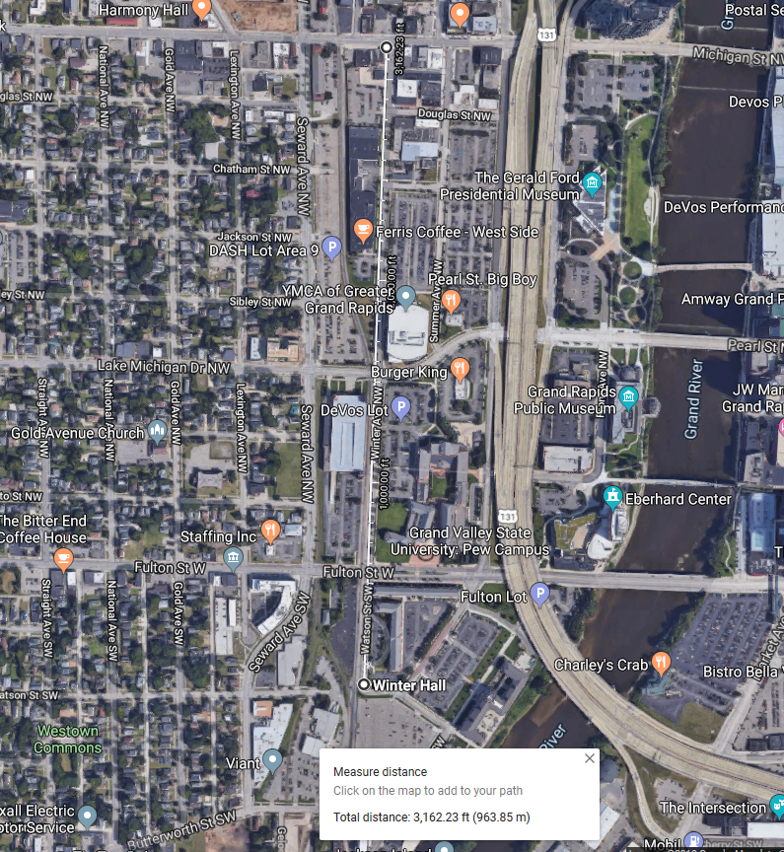

**Figure 2: Distance of VHF testing**

The above map indicates theVHF had a strong signal up to roughly 3,162 feet: 0.61 miles. The signal remained strong in a city environment, thus could possibly be traced further than the verification test in an open environment.

### 1.2.2 VHF On Signal Time

VHF on signal time was validated using a simple lab test which involved the use of an oscilloscope. The VHF ON frequency and time duration of the signal is shown in the figure below.

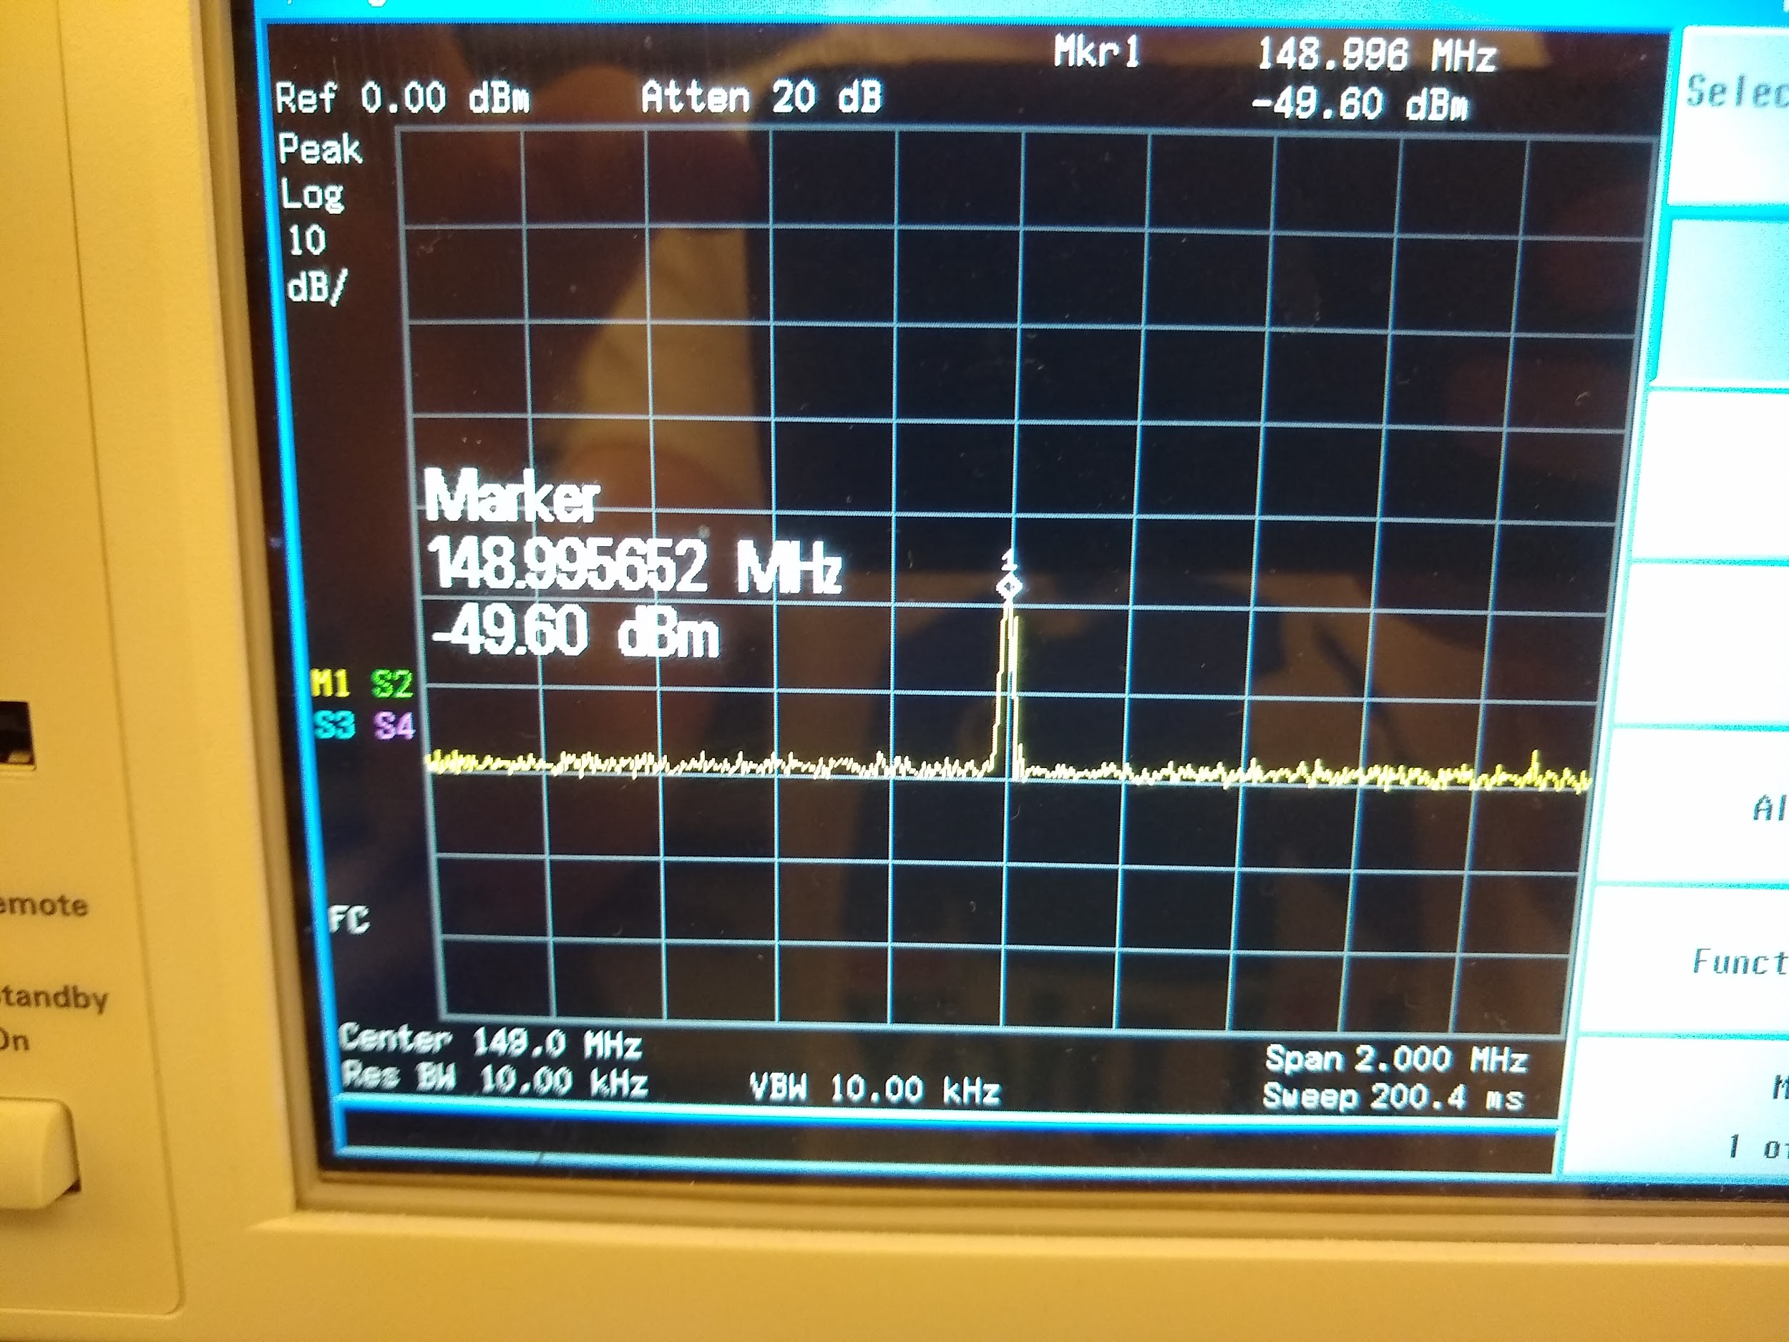

**Figure 3: VHF ON signal**

### 1.2.3 VHF Off Signal Time

VHF off signal time and frequency was validated in the same was the the on signal time. The results of this lab tests are also shown above. VHF remains quiet for 2 seconds, and sends a frequency determined by the technician at the interval (20ms duration).

## 1.3 XBee Range

XBee range was validated through a field test in the IDC building (non-open environment). Data was traced up to 150 meters and was still holding a signal. Further open space testing would validate a data acquisition range longer than 150 meters.

## 1.4 Deployment Test

GPS Fixes were saved only if they were more accurate than 50 meters, this is a power saving measure, however fixes were shown to be within 10 meters of true location via map entry cross-checking. When the VHF beacon was activated it was validated in the same manner as 1.2.1. Xbee range was verified via downloading in the same method as 1.3. It was crosschecked via the direct memory access on the debugger to contain the entire data set.

2. Battery Life Validation

Battery life of the device was tested using various current draw scenarios per the operating parameters specified below. The standard operating parameters are shown in Table X, and were used to calculate the estimated default battery life of the device. Furthermore, additional modes were tested to show battery life (and shelf life) estimations for the worst case active mode, and “off” mode respectively. These values were also used to create as battery life calculator to estimate the life of the device in the field given configured parameters. The sections detailing the battery life estimations are shown below.

**Table 2:** Operating Parameters for Medium Device

|  |  |  |  |
| --- | --- | --- | --- |
| **Operating Parameter** | **Minimum Value** | **Default Operation Value** | **Maximum Value** |
| GPS Fixes Per Day (Fixes/Day) | 0 | 6 | 144 |
| Active VHF Beacon Window (Hrs/Day) | 0 | 4 | 24 |
| Active VHF Beacon Days per Week (Days/Week) | 0 | 1 | 7 |
| Environmental Temperature (°C) | -10 | 25 | 30 |

**Table 3: Operating Parameters for Small Device**

|  |  |  |  |
| --- | --- | --- | --- |
| **Operating Parameter** | **Minimum Value** | **Default Operation Value** | **Maximum Value** |
| GPS Fixes Per Day (Fixes/Day) | 0 | 3 | 144 |
| ~~Active VHF Beacon Window (Hrs/Day)~~ | ~~0~~ | ~~4~~ | ~~24~~ |
| ~~Active VHF Beacon Days per Week (Days/Week)~~ | ~~0~~ | ~~1~~ | ~~7~~ |
| Environmental Temperature (°C) | -10 | 25 | 30 |

## 2.1 Default Battery Life Validation

At the default operating parameters, using measured values from the device, the medium and small devices’ lifespans are calculated in the table below.

Table 4: Medium Collar Default Lifespan

|  |  |
| --- | --- |
| **Medium Collar Lifespan** | |
| GPS Fixes per Day: | 6 |
| VHF Days per Week: | 1 |
| VHF Hours per Day: | 2 |
|  |  |
| Battery Capacity (mAh): | 2400 |
|  |  |
| **Operational Life (Days):** | **159.84** |

Table 5: Small Collar Default Lifespan

|  |  |
| --- | --- |
| **Small Collar Lifespan** | |
| GPS Fixes per Day: | 3 |
|  |  |
| Battery Capacity (mAh): | 1200 |
|  |  |
| **Operational Life (Days):** | **89.71** |

## 2.2 Worst Case/High Performance Activity Battery Life

The worst case scenario was also calculated to determine the worst case battery life if the researcher wanted to obtain large amounts of data. The theoretical lifespan of the devices is shown below.

**Table 6:** Medium Collar Worst Case Lifespan

|  |  |
| --- | --- |
| **Medium Collar Lifespan** | |
| GPS Fixes per Day: | 144 |
| VHF Days per Week: | 7 |
| VHF Hours per Day: | 24 |
|  |  |
| Battery Capacity (mAh): | 2400 |
|  |  |
| **Operational Life (Days):** | **17.70** |

**Table 7:** Small Collar Worst Case Lifespan

|  |  |
| --- | --- |
| **Small Collar Lifespan** | |
| GPS Fixes per Day: | 144 |
|  |  |
| Battery Capacity (mAh): | 1200 |
|  |  |
| **Operational Life (Days):** | **36.41** |

## 2.3 STOP Mode Battery Shelf Life

The STOP mode of the device was also calculated to give a shelf life estimation. The following tables are shown below given the calculated shelf lives of the collars.

**Table 8:** Medium Collar STOP Lifespan

|  |  |
| --- | --- |
| **Medium Collar Lifespan** | |
| GPS Fixes per Day: | 0 |
| VHF Days per Week: | 0 |
| VHF Hours per Day: | 0 |
|  |  |
| Battery Capacity (mAh): | 2400 |
|  |  |
| **Operational Life (Days):** | **200.00** |

**Table 9:** Small Collar STOP Lifespan

|  |  |
| --- | --- |
| **Small Collar Lifespan** | |
| GPS Fixes per Day: | 0 |
|  |  |
| Battery Capacity (mAh): | 1200 |
|  |  |
| **Operational Life (Days):** | **100.00** |

3. Packaging Validation Testing

Mechanical integrity and packaging were validated to ensure the collar and enclosure can withstand the environment of Northern Michigan and attack from predators. Packaging validation tests conducted include: enclosure predator bite force testing, collar strap tensile testing, claw snag testing, and waterproof testing. Finally, the mass of the collar assembly was verified to be under 125 grams. The sections for the respective tests are shown below.

## **3.1** Bite Force Testing

**3.1.1** Preliminary simulation showed that the enclosure would withstand a predator bite of 400 lbs. The simulation was performed using ansys. The bite was simulated as a static structural load modeled using 8 point loads. The enclosure withstood the bite force for the simulation with a factor of safety of 2. The total deformation was 0.155 mm, and the maximum equivalent stress was 38 MPa. The FEA results were validated using physical experimentation.

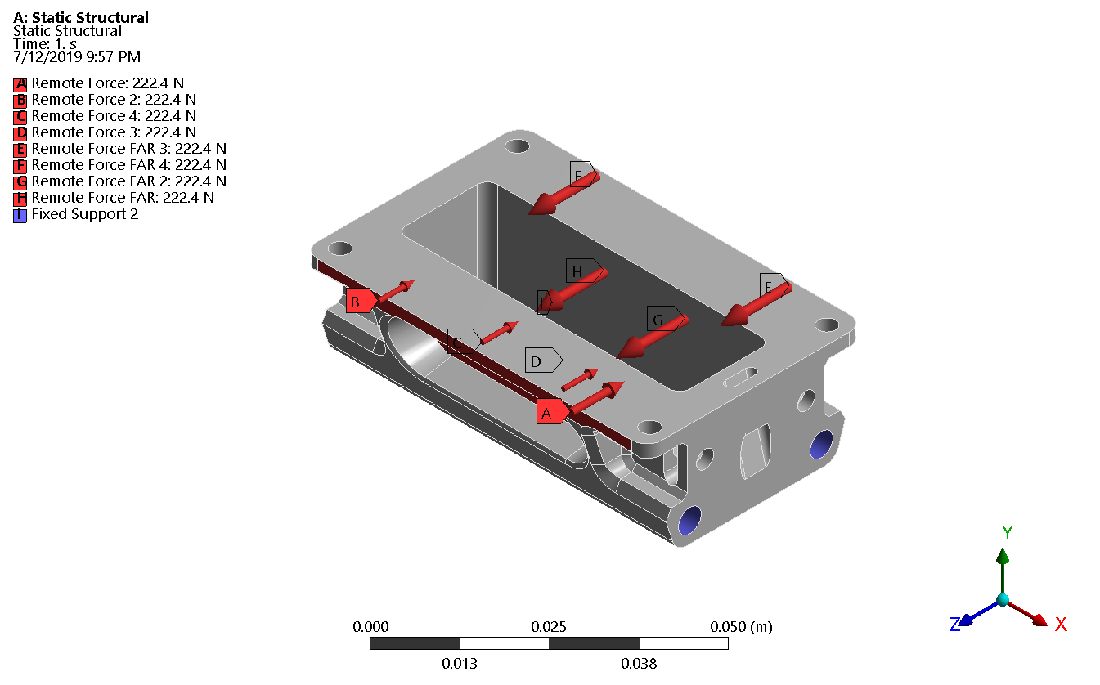  
**Figure 4.** Finite element analysis boundary conditions and loads.

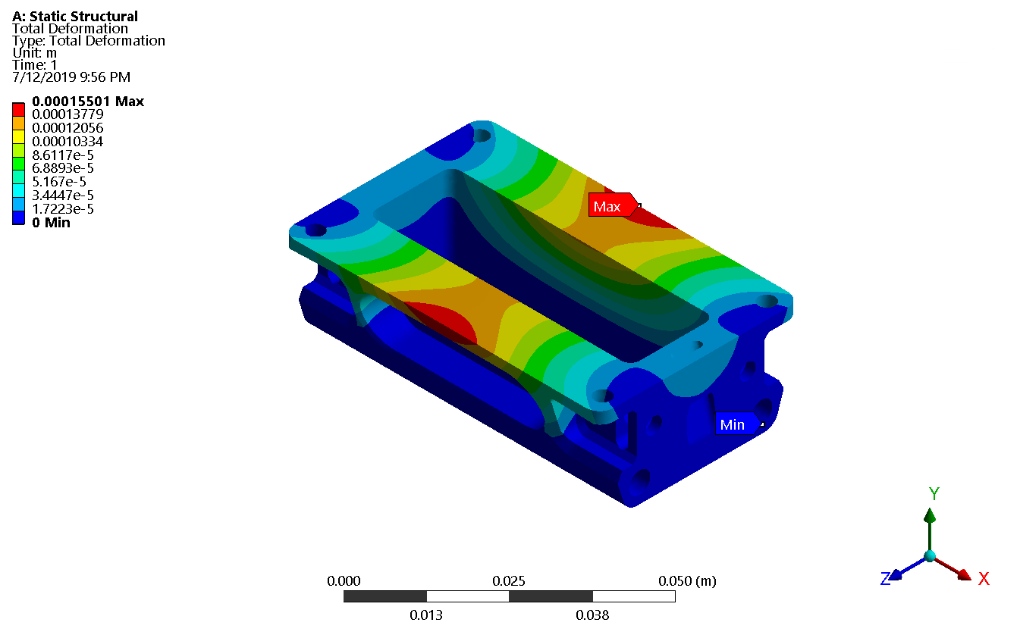  
Figure 5. Finite element analysis total deformation

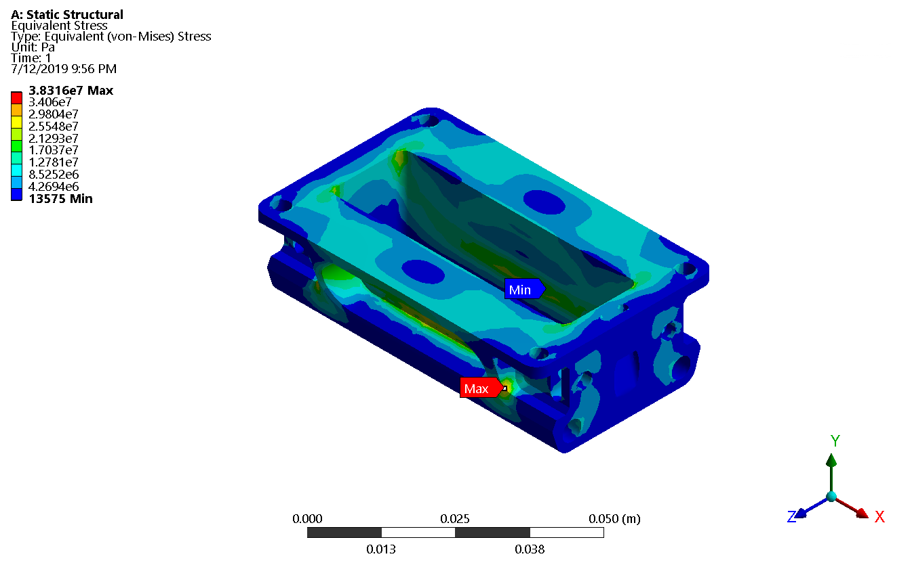  
Figure 6. Finite element analysis total equivalent stress.

**3.1.2**  The enclosure was then 3D printed using 20% by weight carbon fiber impregnated ABS. A specialized jig was made to simulate the bite of a predator in a similar fashion modeled in ansys. The jig was used with an Instron 5982 series compression and tensile tester to validate the design. During the test the enclosure carried a sustained load of 400 lbf, with a peak load of 430 lbf. This validated the simulation results.

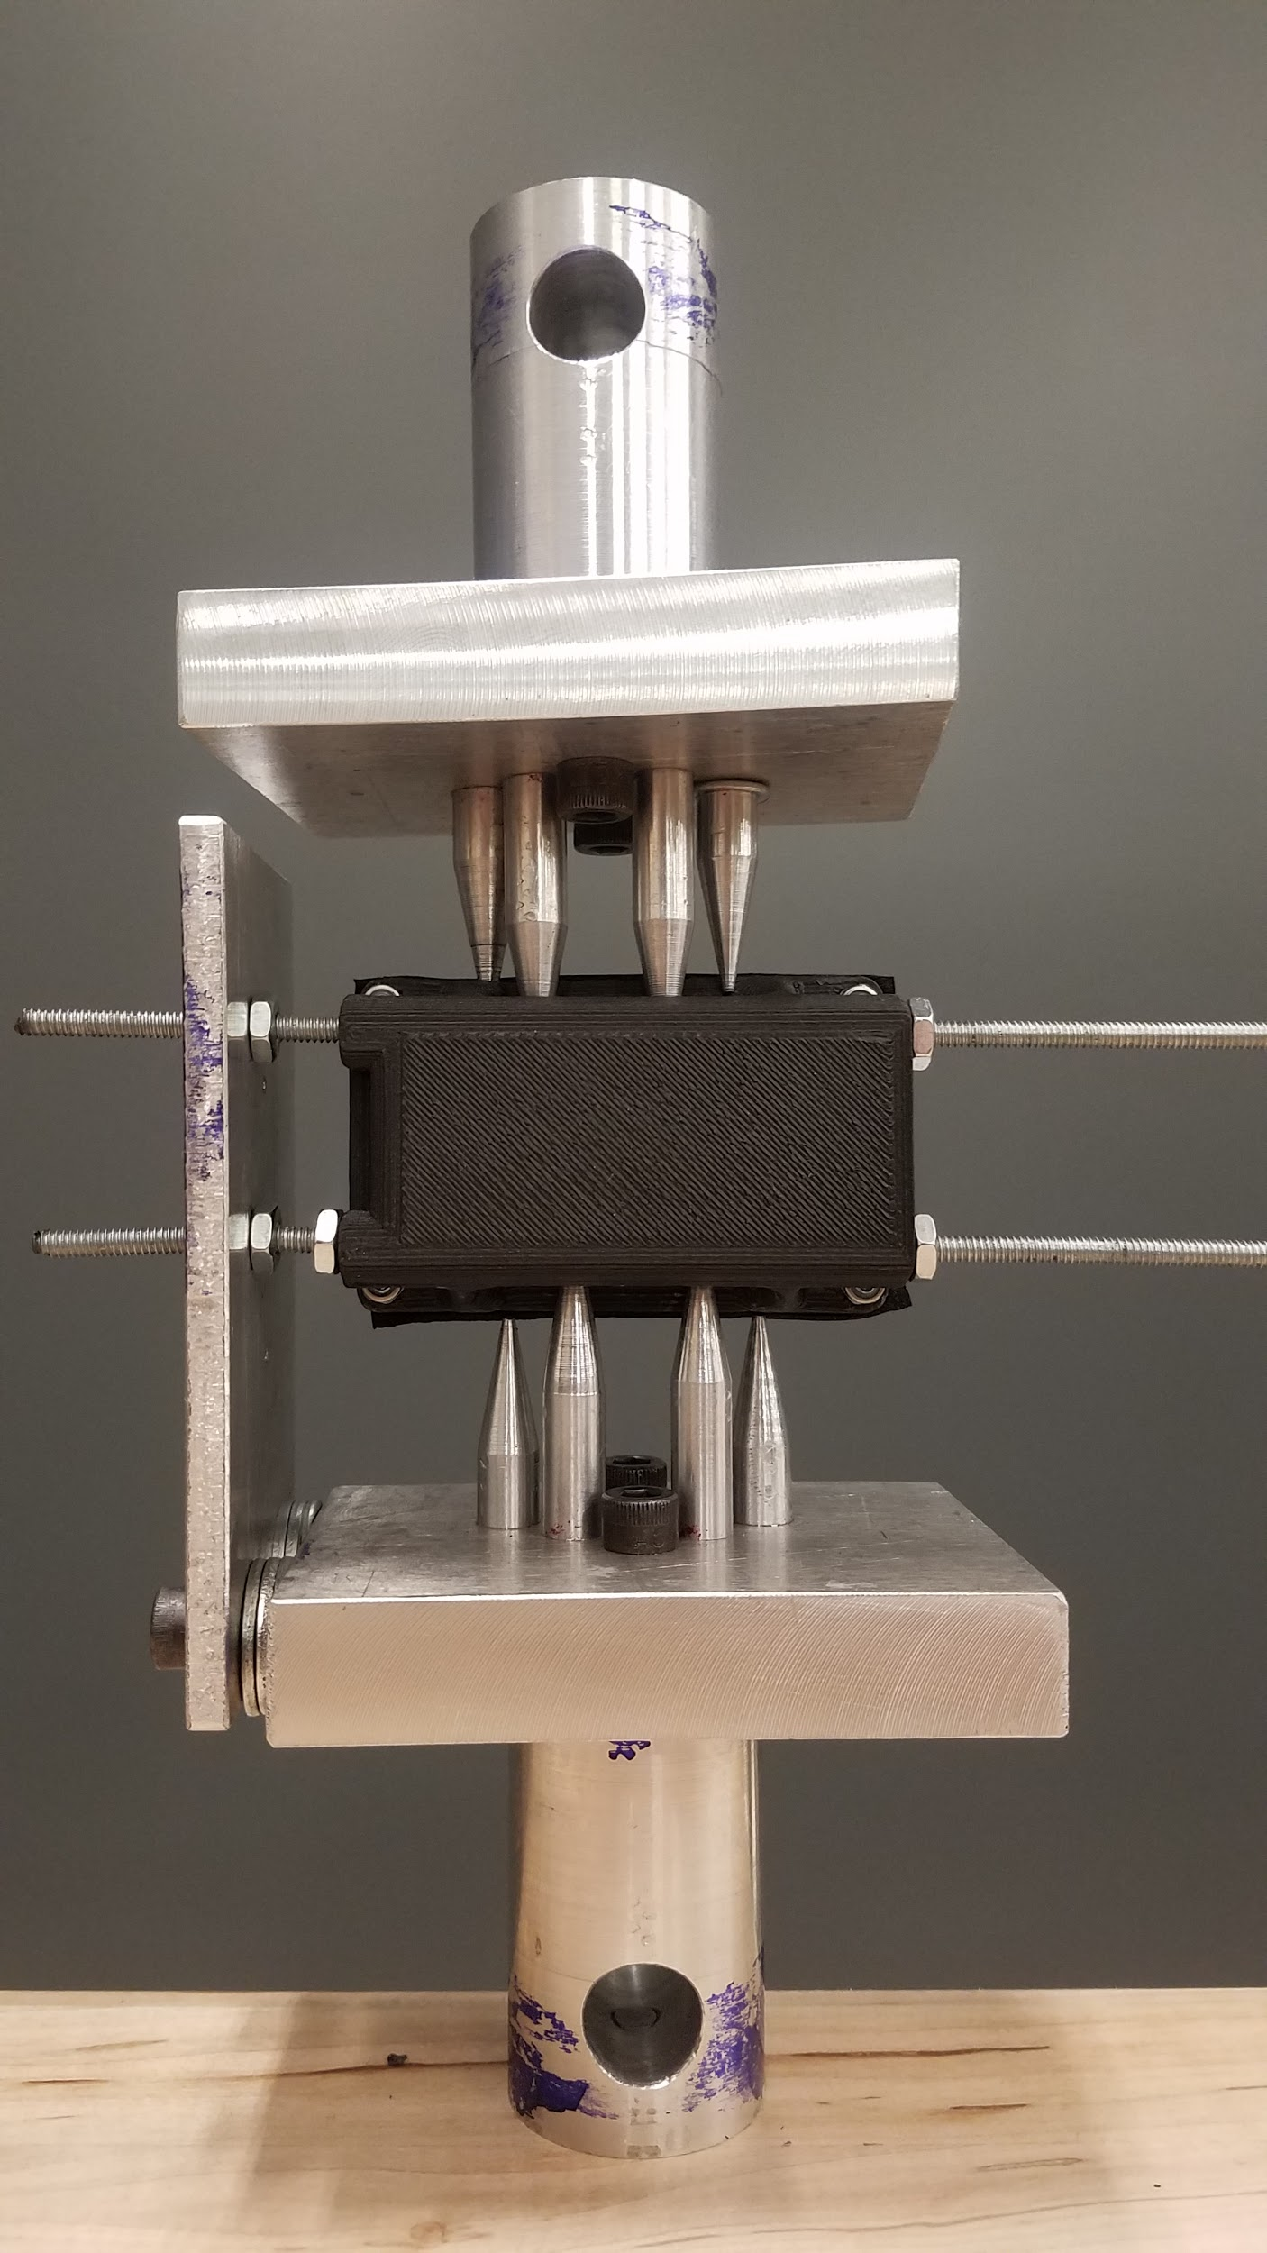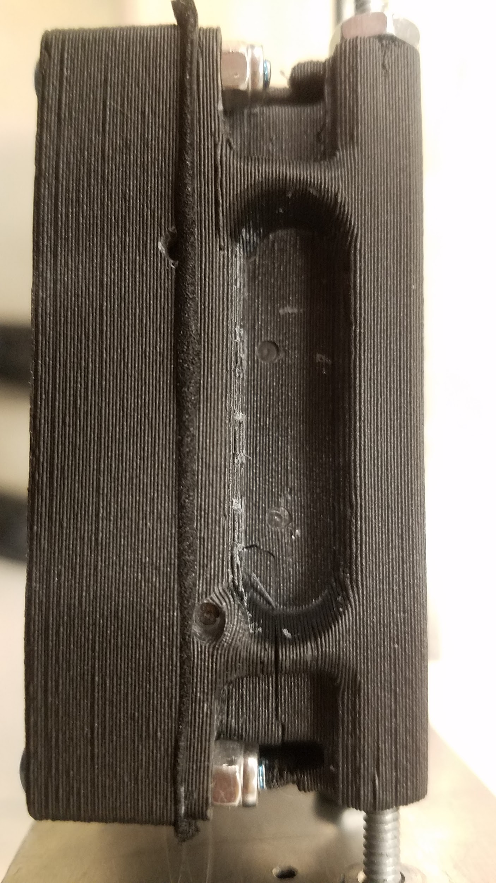

**Figures 7 and 8.** Testing apparatus (Left) used in Instron for bite testing and enclosure after failure (Right).

## 

## 3.2 Collar Tensile Testing

**3.2.1** The collar tensile test was performed using a hanging mass of 15 lbs. The mass was strung up using a light wire. The wire passed through the middle of the collar and the collar was lifted by the enclosure. The whole weight of the mass was held by the stud plate connection. At this connection point only one layer of strapping on the sleeved side has holes and is the weakest point. The hanging mass was suspended by the collar strap, verifying the hand calculations and validating the strap design.

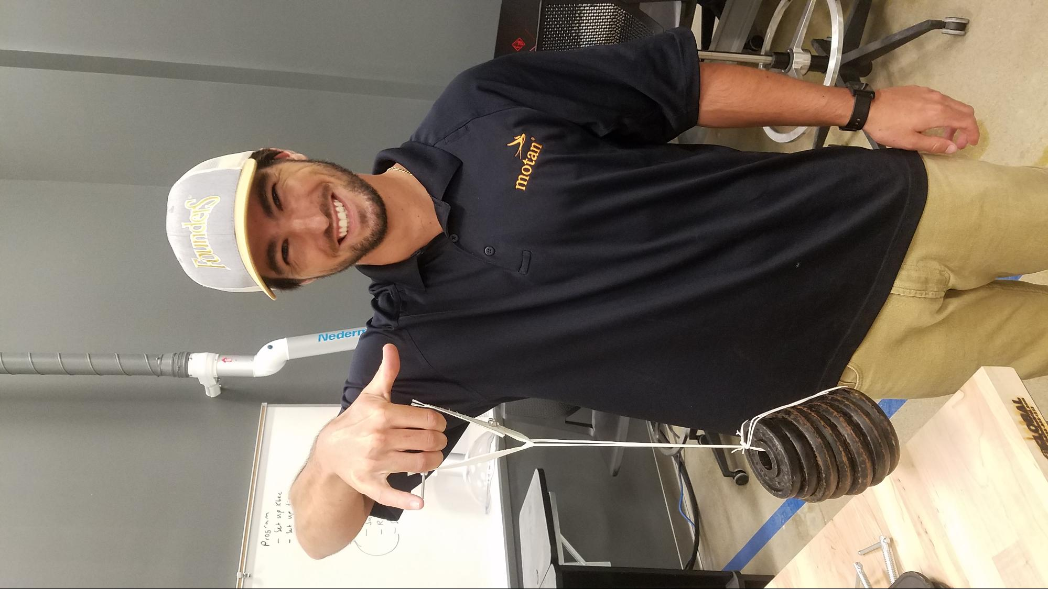

**Figure 9.** Tensile test performed with a 15 lb mass.

## 3.3 Claw Catch Testing

Claw catch validation was performed via a simple test using the collar belting material and a fish hook. The fish hook mimicked a young Bobcat’s sharp claw scratching the outer surface of the collar. A fish hook was firmly dragged across the collar belting material to ensure a sharp, curved object would not catch or snag on the belt. A display of the test is shown below.

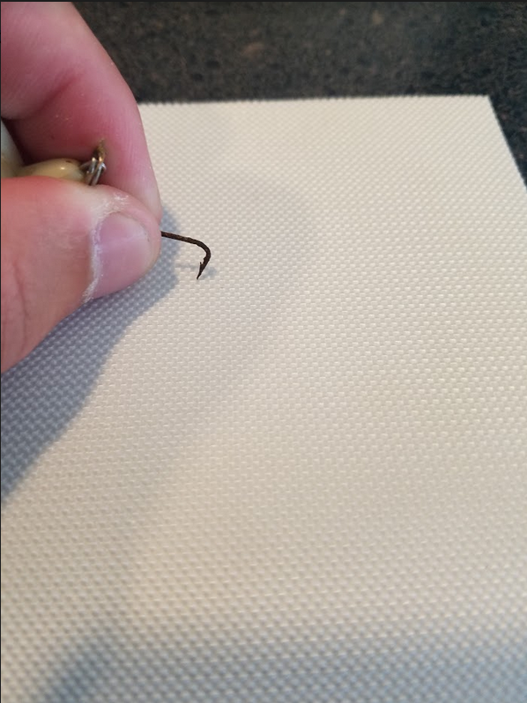

**Figure 10:** Claw Catch Validation Test

The hook did not catch or snag the collar material and was validated a kitten’s claws would not become stuck in the collar material. The claw catch test validated that no kitten claws, or any sharp object would get caught or ‘snagged’ in the collar strap material.

## 3.4 Waterproof Testing

In each waterproofing test the enclosure was fitted with a gasket and a small amount of dry tissue paper placed inside. If the paper remained dry after a test the enclosure passed. If the paper was wet, the enclosure failed.

**3.4.1** The enclosure was placed in a basin of water at a depth of 0.5 meters. The enclosure remained underwater for 60 seconds and was then retrieved. The paper within the enclosure remained dry. No water made ingress, the enclosure passed.  
**3.4.2** The second test was performed using a hose with a constant stream of water. The enclosure was sprayed from all sides with the hose for 3 minutes . The paper within the enclosure remained dry and the enclosure passed.

**3.4.3** For the third test the enclosure was placed in water 0.5 meters deep for ten minutes. The enclosure was retrieved from the water and the paper was found to be wet. The enclosure failed this test.

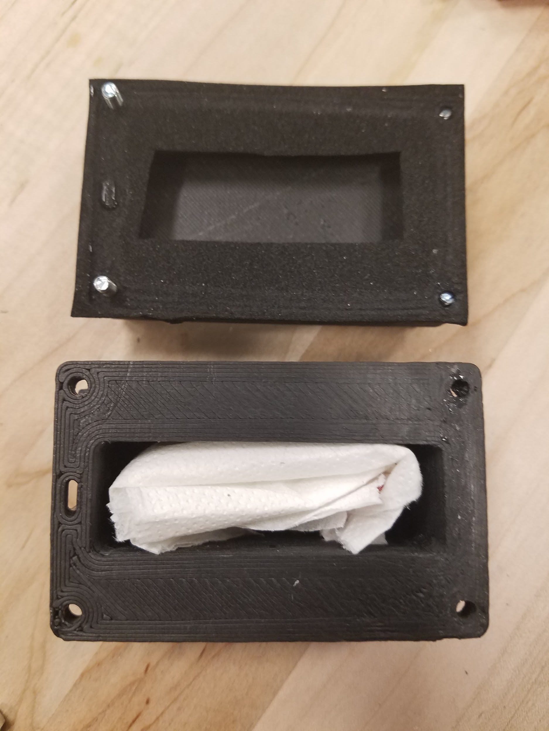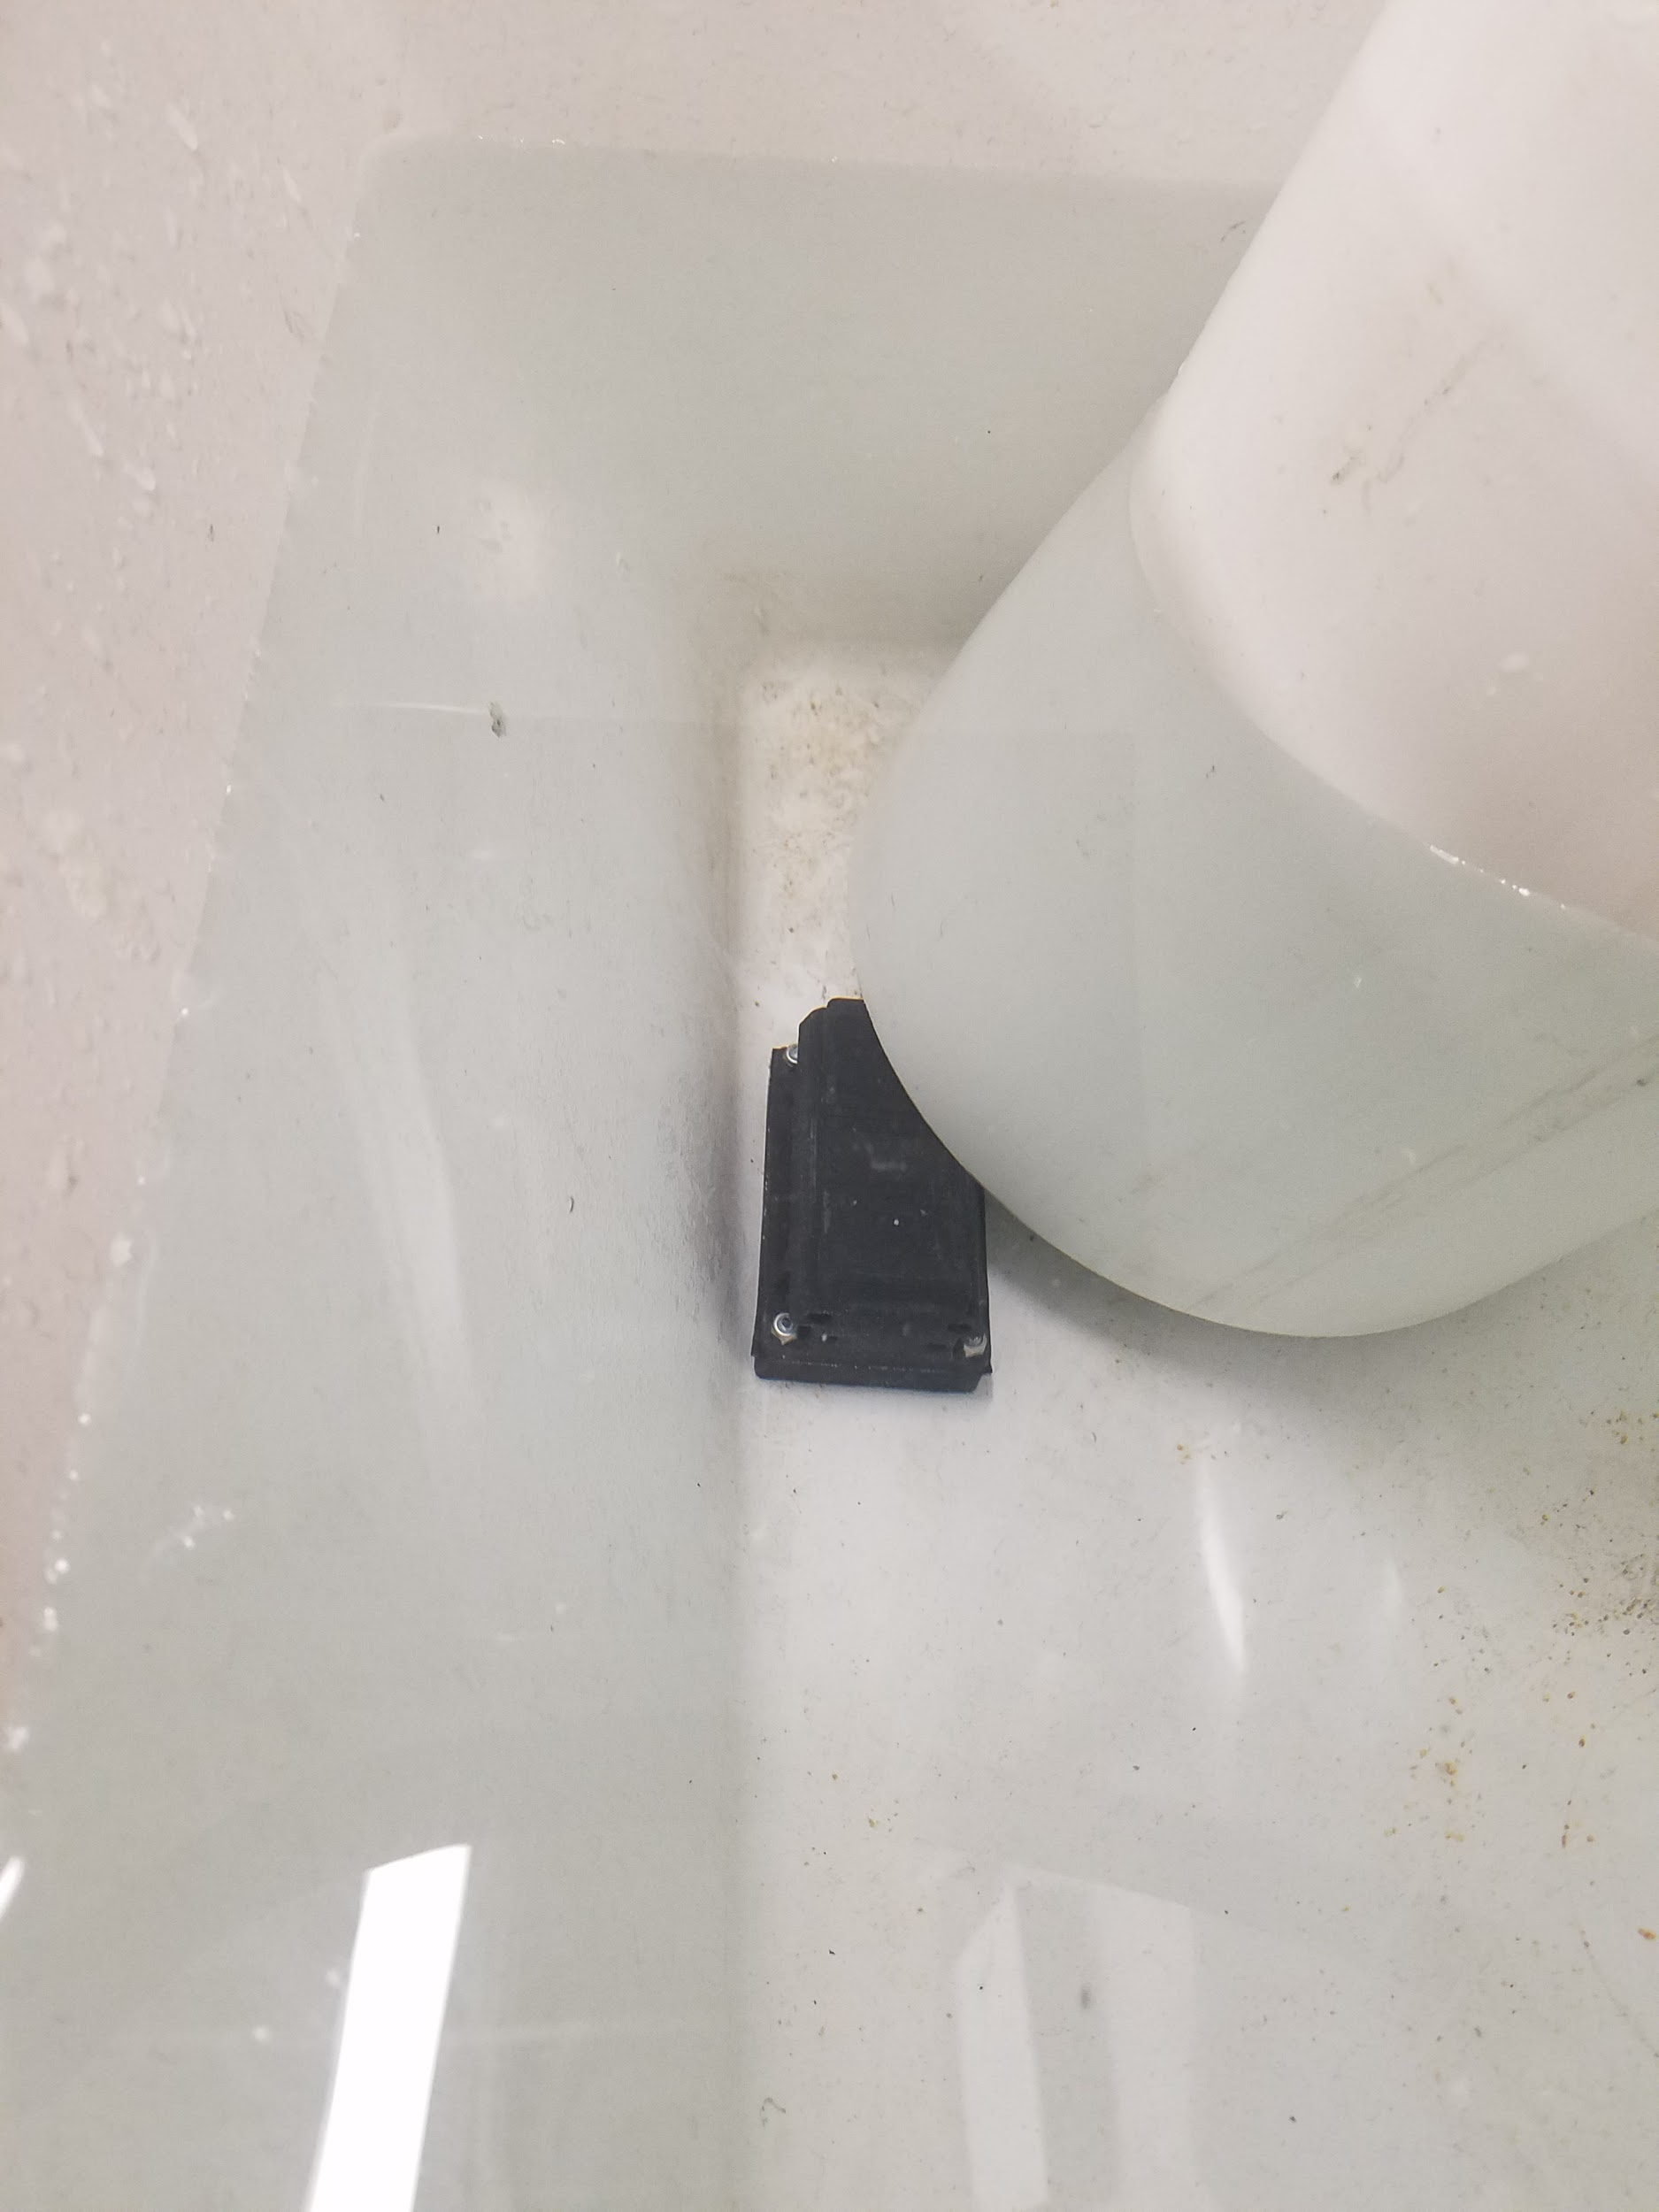  
**Figures 11 and 12:** Enclosure with tissue paper (Left) and underwater (Right)

## 

The enclosure can be given an IP66 rating. No harmful dust or particles will enter the enclosure and it will withstand moderate water exposure. Prolonged immersion in water will result in failure of the seal.

## 3.5 Mass Validation (Medium Collar)

Mass of the entire collar was validated per component, then as an entire device. The medium collar weight, and small collar weight, was validated using a gram scale in a lab setting. A table of the medium device broken down by component weight is shown in the detailed design document. This table shows that the total mass of the collar is below the specified 125 grams. The entire device was measured on a gram scale and can be shown in Figure 13 - attaining a mass of 120.6 grams; within the 125 gram specification.

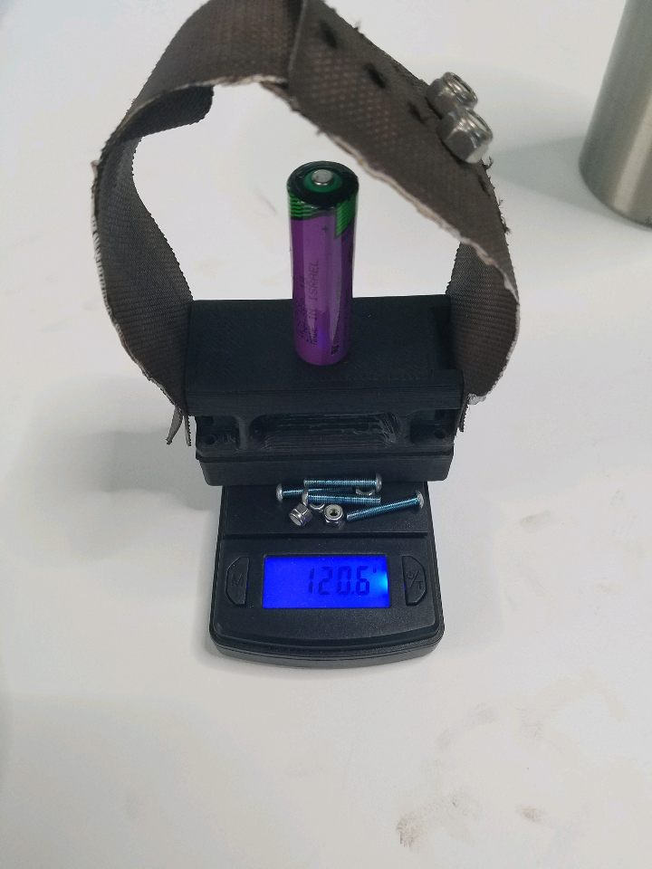

**Figure 13: Photograph of medium collar assembly on gram scale**

### 3.5.1 Mass Validation (Small Collar)

The small collar’s mass was validated with the same methodology as the large collar: per component and the device as a whole. A table of the small device broken down by component weight is shown in the detailed design document. This table shows that the total mass of the collar is below the specified 35 grams. The entire device was measured on a gram scale and can be shown in Figure 14 - attaining a mass of 28.3 grams; within the 35 gram specification.

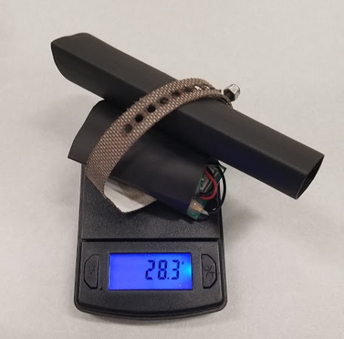

**Figure 14: Photograph of small collar assembly on gram scale**

## 3.6 Volume Validation (Medium Collar)

The volume of the entire collar enclosure was within 110,356 mm3. The collar enclosure meets the required specification for enclosure size.

### **3.6.1 Small Collar**

The dimensions of the small collar is within the specified requirement of 40mm x 25mm x 25mm. The enclosure volume meets the required specification.

## 3.7 Color Validation

The color of the device as a whole is shown below. The color of the device was specified to be muted earth toned, allowing it to blend in with nature and the animal of study. A picture of the collar in its final color is shown in Figure 15.

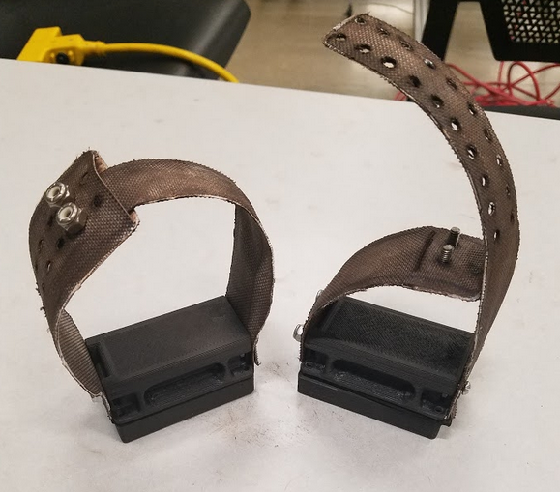

**Figure 15: Muted earth tone final collar assembly**